Paper Title: It Should Fit on One Line [X Paper Title]
First Author’s First Name(s) LAST NAME LEAVE BLANK FOR INITIAL SUBMISSION
Author's affiliation LEAVE BLANK FOR INITIAL SUBMISSION
Author’s e-mail address LEAVE BLANK FOR INITIAL SUBMISSION
Second Author’s First Name(s) LAST NAME LEAVE BLANK FOR INITIAL SUBMISSION
Author's affiliation LEAVE BLANK FOR INITIAL SUBMISSION
Author’s e-mail address LEAVE BLANK FOR INITIAL SUBMISSION
Abstract: Please prepare an abstract of at most 2000 characters. Please avoid citing references in your abstract. The deadline to submit the full paper is 9 December, 2024, Monday. Please use Styles provided in this document to format the text. Please anonymise your paper before submitting. [X Abstract]
Keywords: maximum 5 keywords; abstract; instructions; full paper template; conference website [X Keywords]

Introduction [X Heading 1]
This template provides instructions for formatting the full paper for the “DRS Learn X Design 2025 Intertwinia in Design Education” call. You may write directly into the template, or copy your finished text into it choosing “match destination formatting” as the paste option. Please do not change the predefined formatting settings in this document (such as paper size, orientation, margins, typeface, size, indents, spacing, headings, etc.).
Please use the predefined formatting styles instead of applying your individual settings. These styles are preceded with “X”, such as [X Paper Title], [X Abstract] or [X Paragraph]. Please do not use colour fonts.
Please submit your paper electronically in Word format using this template. Check the website for the different formats of submission. For example, the full papers should be between 3000-6000 words in length, plus references.

Formatting Styles [X Heading 2]
The template uses A4 size paper in portrait orientation, with the margins being 2,5 cm from the top, and 2 cm for the left, right and bottom of the page; the header and footer are set at 1,5 cm. All formatting styles for the full paper are provided in the “styles” menu above. Single line spacing is used throughout the document, with 12 pt spacing between paragraphs.
The format for referencing and the reference list in this journal is the APA style, 7th edition, which is described in the latest version of the American Psychological Associations Publication Manual. The style is also described, explained and examples of use are shown on the website https://apastyle.apa.org/(American Psychological Association, 2020). See also examples of how different types of references should be formatted in the reference list under References at the end of this document. References are placed in parentheses (Oxman, 2000) in the running text, in the same format as the surrounding text. Endnotes should be avoided and never used for referencing.
The papers will be published in the event proceedings with DOI numbers.
Paragraphs [X Heading 3]
The formatting style for the main text of the full paper is [X Paragraph], using Calibri as the main font type, with 10 as font size, and in single line spacing, with 12 pt spacing between paragraphs. Please do not use ‘these marks’ in the text and instead prefer using italics to emphasize.
Bullet Lists [X Heading 3]
- For your lists with bullet points, please use the style [X Bullet list].
- And so on.
- Et cetera.
Numbered lists [X Heading 3]
- For your lists with numbers please use the style [X Numbered list].
- And go on with your list.
- For as long as necessary.

Figures and Tables [X Heading 2]
Figures and tables in your full paper must also be formatted appropriately.
Figures and Figure Captions [X Heading 3]
After you insert a figure into the document, select it and use style named [X Figure]. Figures are followed by a caption placed below. Please do not forget to refer to your figure in the text (Figure 1). The figures should be numbered as Figure 1, Figure 2, and so on (Figure 2). Since the proceedings are going to be published electronically you may use colour pictures. However, please make sure that their resolution is good enough to be legible when printed. We recommend a resolution of 300 dpi, with the shortest side of the figure being 6 cm.
Please be selective and to the point in the usage of figures. The figure caption is placed below the relevant figure, and uses the style [X Figure caption]. If the figure is from a source, please do not forget to give reference in the figure caption. If you are using diagrams, info graphics, or other schematics please ensure that you present information clearly, you use the Calibri font, and all text is legible (i.e. appropriate size and not cropped)
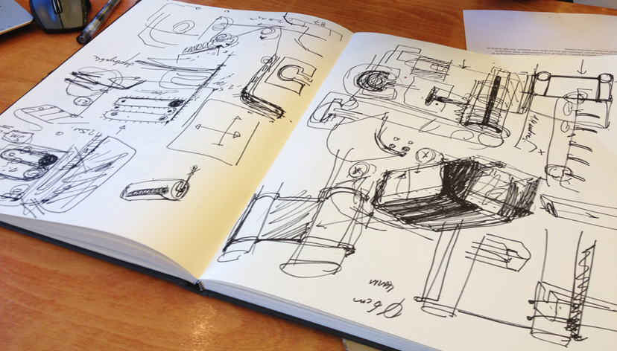
Figure 1. The most critical pages of the sketchbook of a student that really had to be shown in this paper (Surname, 2006, p. xx). [X Figure caption]
Tables and Table Captions [X Heading 3]
Please use Word generated tables in your paper. The formatting style for tables is [X Table]. The title should be placed directly above a table [X Table title]. Please do not forget to refer to a table in the text (Table 1).
Table 1. The distribution of items into subtitle categories. [X Table title]
 | Subtitle 1 | Subtitle 2 | Subtitle 3
Item 1 | 4 | 5 | 6
Item 2 | 5 | 6 | 4
Item 3 | 6 | 4 | 5
Total | 15 | 15 | 15

Referencing [X Heading 1]
Please follow the APA style 7th edition author-date documentation system for referencing in your text. Within the main text, references should be placed in parentheses (Jones, 2012). For a work by two authors, use the word "and" between the authors' names within the text and use the ampersand (“&”) in the parentheses. In the text reference format for a source with three to five authors, for the first time, list all the authors such as Williams, Wikström, Otterbing, Löfgren and Gustafsson (2012), and then list only the first author followed by et al., such as: Williams et al. (2012). For six or more authors use the first author's name followed by et al. You may reach detailed information on APA at https://apastyle.apa.org/

Quotations [X Heading 2]
If there is direct quotation in the text, please indicate page number (Author, Year, p. xx). Short quotations should take place in the text body (paragraph) and be indicated with “quotation marks” (Author, Year, p. xx).
For long quotations (those that are more than 40 words), please use a separate block paragraph. The formatting style for long quotations is [X Long quotation]. Do not use quotation marks for this paragraph. The reference must be given at the end of the quotation (Author, Year, p. xx).

Paraphrasing (Indirect Quotations) [X Heading 2]
Please give reference to a source as (Author, Year). Do not use quotation marks for paraphrasing (indirect quotation). Page numbers are optional when paraphrasing, although it is useful to include them. For example, Gigerenzer (1999; cited in Stempfle & Badke-Schaub, 2002, p. 488), claims that many examples of heuristics that humans apply have the common purpose of reducing complexity, and saving time and cognitive effort in the face of incomplete information.
If English is not your first language, or you are not fluent in references, we suggest that you send your paper to Scribendi at http://www.scribendi.com or a similar proof-reader before submission.
Acknowledgements: This section is optional. You can use this section to acknowledge help from your colleagues, students’ participation, internal or external partners’ contribution or funding which supported the research outlined in the paper[Leave blank for initial submission] [X Acknowledgment].

References [X Heading 1]
The references below are provided as examples. Please provide a single list of references and do not group them according to type of source. Remember to give references in alphabetical order.
Book
Ulrich, K.T., & Eppinger, S.D. (2004). Product Design and Development (3rd ed.). McGraw-Hill/Irwin.
Edited book
Menges, A., & Ahlquist, S. (Eds.) (2011). Computational Design Thinking. John Wiley & Sons.
Translated book
Rancière, J. (1991). The Ignorant Schoolmaster: Five Lessons in Intellectual Emancipation (K. Ross, Trans.). Stanford University Press.
Chapter in a book
Adams, R., Mann, L., Jordan, S., & Daly, S. (2009). Exploring the Boudaries: Language Roles and Structures in Cross-Disciplinatry Design teams. In J. McDonnell & P. Lloyd (Eds.), About Designing: Analysing Design Meetings (pp. 339–358). Taylor & Francis.
Alexander, C. (2011). Systems generating systems. In A. Mengers & S. Ahlquist (Eds.), Computational Design Thinking (pp. 58–67). John Wiley & Sons.
Journal article
DiSalvo, C. (2014). Critical making as materializing the politics of design. The Information Society: An International Journal, 30(2), 96-105. DOI: 10.1080/01972243.2014.875770
Stempfle, J., & Badke-Schaub, P. (2002). Thinking in Design Teams - An Analysis of Team Communication. Design Studies 23(5), 473-496. DOI: 10.1016/S0142-694X(02)00004-2
Williams, H., Wikström, F., Otterbing, T., Löfgren, M., & Gustafsson, A. (2012). Reasons for household food waste with special attention to packaging. Journal of Cleaner Production, 24(March), 141-148. DOI: 10.1016/j.jclepro.2011.11.044
Article in the special issue of a journal
Menges, A. (Ed.). (2012). Material Computation: Higher Integration in Morphogenetic Design [Special Issue]. Architectural Design, 82(2), 1-144.
Conference paper
Börekçi, Naz A.G.Z. & Korkut, F. (2017). Collaborating with external partners in industrial design education: A review of success factors. In G. Pritchard & N. Lambert (Eds.), Proceedings of LearnX Design London 2017 Conference (pp. 183-191). Ravensbourne, 27-30 June 2017. Ravensbourne Publications.
Morelli, N. & DeGötzen, A. (2017). A multilevel approach for social transformations and its implications on service design education. In L. Di Lucchio, L. Imbesi & P. Atkinson (Eds.), Design for Next: Proceedings of the 12th European Academy of Design Conference (pp. 803-813). Sapienza University of Rome, 12-14 April 2017.
Peter, A., Lotz, N., McDonnell, J. & Lloyd, P. (2013). The effect of prototyping material on verbal and non-verbal behaviours in collaborative design tasks. In Proceedings of 5th International Congress of International Association of Societies of Design Research (IASDR) (pp. 2382-2393). 26-30 August 2013, Tokyo, Japan.
Thesis or dissertation
Oxman, N. (2010). Material-based design computation (Unpublished PhD. dissertation). Retrieved from: https://dspace.mit.edu/handle/1721.1/59192#files-area
Töre, G. (2006). User workshops: Procedure for eliciting user needs and user defined problems (Unpulished MS thesis). Middle East Technical University, Ankara, Turkey.
Online source
Kolawole, E. (2016). Where inclusion meets human-centered design – Stanford d.school – Medium. Retrieved June 11, 2018, from https://medium.com/stanford-d-school/where-inclusion-meets-human-centered-design-518a4c1c93a1
Romanik, R. (2013). 12 best practices for retail-ready packaging. Packaging World: Packaging News, Trends and Innovation (online magazine). Retrieved October 24, 2013, from http://www.packworld.com/package-design/retail-ready/12-best-practices-retail-ready-packaging.
The Warwick Commission (2015). Enriching Britain: Culture, Creativity and Growth. The 2015 Report by The Warwick Commission on the Future of Cultural Value. Coventry: The University of Warwick. Retrieved from http://www2.warwick.ac.uk/research/warwickcommission/futureculture/finalreport/enriching_britain_-_culture_creativity_and_growth.pdf
About the Authors Leave blank for initial submission] [X About title]
First Name Last Name Please add in this section, a short biography for each author, in order Leave blank for initial submission] [X Author Bio]. The short biography should be maximum 60 words for one author.
First Name Last Name Please add in this section, a short biography for each author, in order Leave blank for initial submission] [X Author Bio]. The short biography should be maximum 60 words for one author.

